1.Dinesh’s monthly salary is 50% more than that of Chappu. Chappu’s salary is 20% less than Guthi. Guthi earns 30% more than Rajesh. Salary of Dinesh is what percent more or lees than that of Rajesh?

1. 50%

2. 56%

3. 54%

4. 48%

5. 62%

Solution:

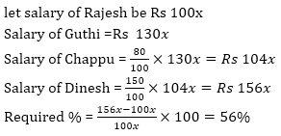

4.If the numerator of a fraction is increased by 20% and the denominator is diminished by 10%, then the value of the fraction is 16/21. The original fraction is:

1. 3/4

2. 4/7

3. 2/3

4. 5/7

5. 3/5

Solution: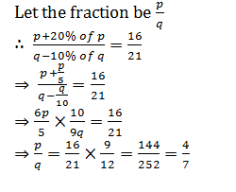

4.Ramesh has 20% savings with him from his monthly salary. If expenditure on clothing is 25% of overall expenditure and his total expenditure except clothing is 3600 then find his saving.

1. 1000

2. 1500

3. 1600

4. 1200

5. 900

Solution: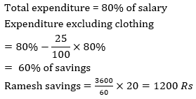

6.Shivam spent 20% & 32% of his total monthly salary on children’s education & food respectively. He spent  of his remaining monthly salary on medical facilities. If difference between amount spent by him on medical facilities and food is Rs.1080, then find amount spent by Shivam on children’s education.

1. Rs.15000

2. Rs.10800

3. Rs.16200

4. Rs.21000

5. Rs.14600

Solution:

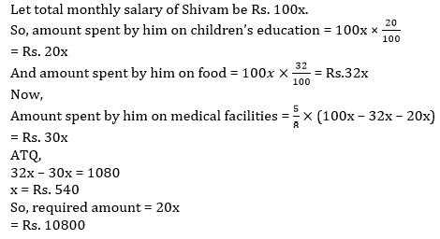

8.In a village, 70% registered voters cast their votes in the election. Only two candidates (A and B) contested the election. A won the election by 400 votes. Had A received 12.5% less votes, the result would have been tie. How many registered voters are there in the village?

1. 4200

2. 4500

3. 4000

4. 4250

5. 3500

Solution:

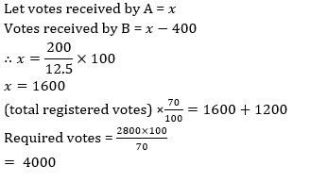

2.A shopkeeper marks up price of LED 60% above its cost price and gives three successive discounts of 12 ½ %, d% and 25%. If shopkeeper made a loss 16% on LED. Find the second discount allowed by shop?

1. 15%

2. 20%

3. 25%

4. 16 ⅔%

5. 17.5%

Solution:

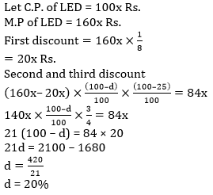

6.In an examination it is required to get 55% of the aggregate marks to pass. A student gets 520 marks and is declared failed by 5% marks. What are the maximum aggregate marks a student can get ?

1. 960

2. 1250

3. 1040

4. cannot be determined

5. None of these

Solution:

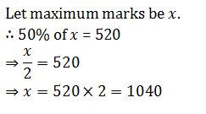

8.Gaurav spends 40% of the amount he received from his father on hostel expense, 20% on books and stationery and 50% of the remaining on transport. He saves Rs. 450 which is half the remaining amount after spending on hostel expenses, books etc. and transport. How much money did he get from his father ?

1. Rs. 3,000

2. Rs. 6,000

3. Rs. 4,500

4. Cannot be determined

5. None of these

Solution:

